

**UNIVERSITY OF PETROLEUM & ENERGY STUDIES**

**Dehradun**

**CONTINOUS INTEGRATION**

**AND**

**CONTINOUS DELIVERY**

**Name: Shivani Chauhan**

**Course: B. TECH CSE DevOps (2018-22)**

**Roll no.: R171218096**

**Sapid: 500068969**

**Experiment-14**

**Deploy Static HTML Website**

**As Container**

**Step-1:** Create your *Dockerfile* for building your image by copying the contents below into the editor.

FROM nginx:alpine

COPY . /usr/share/nginx/html

The first line defines our base image. The second line copies the content of the current directory into a particular location inside the container.

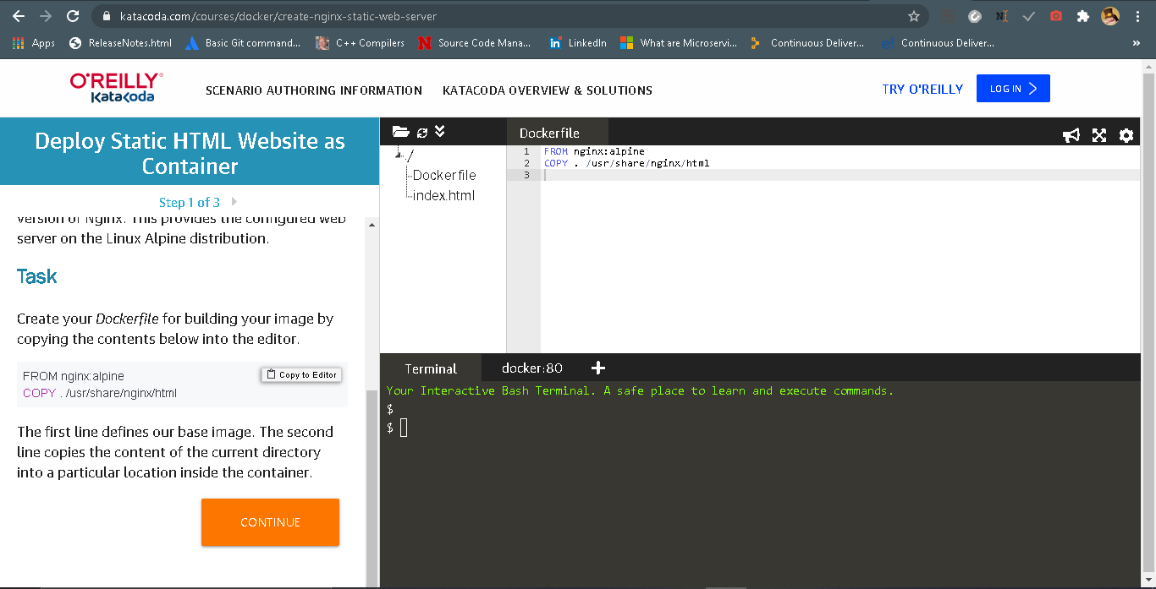

**Step-2:** Build our static HTML image using the build command below.

docker build -t web:v2 .

You can view a list of all the images on the host using docker images.

The built image will have the name web with a tag of v2.

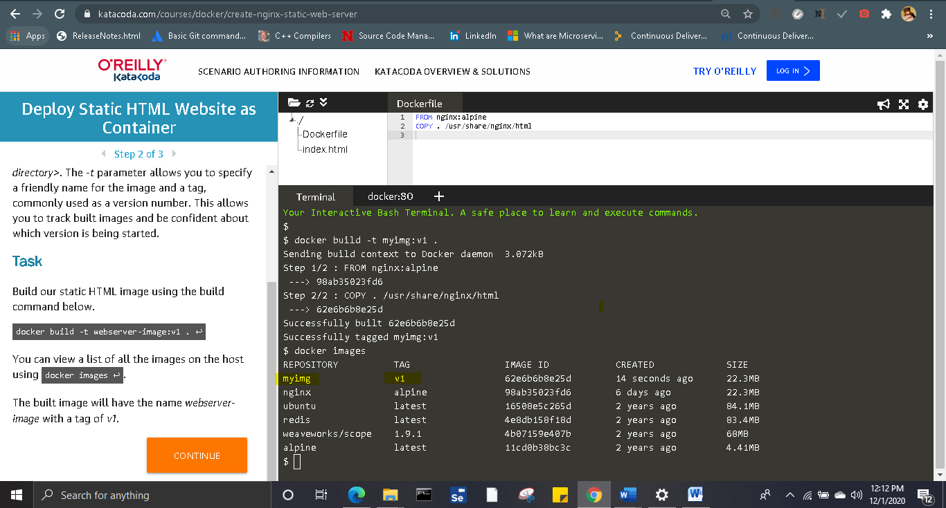

**Step-3:** Launch our newly built image providing the friendly name and tag. As it's a web server, bind port 80 to our host using the -p parameter.

docker run -d -p 80:80 web:v2

Once started, you'll be able to access the results of port 80 via curl docker

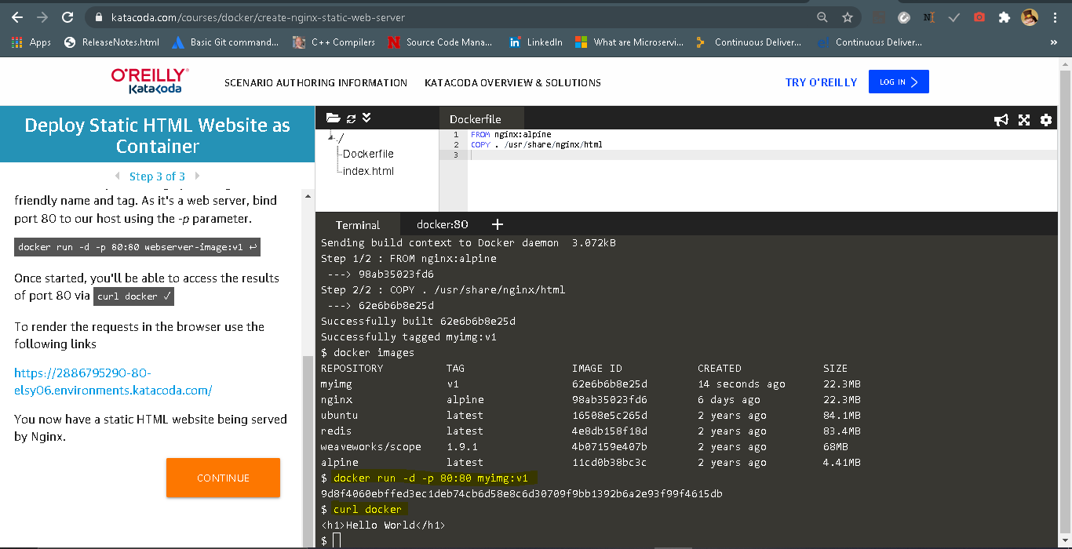

**Step-4:** Push image to docker hub

